**Pizza Sales Queries**

1. **KPI’s**
2. **Total Revenue :-**

**SELECT SUM(total_price) AS Total_Revenue FROM pizza_sales;**

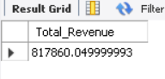

1. **Average Order Value :-**

**SELECT (SUM(total_price)/COUNT(DISTINCT(order_id))) AS Avg_order_val FROM pizza_sales;**

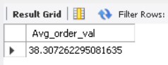

1. **Total Pizzas Sold :-**

**SELECT SUM(quantity) AS Total_pizza_sold FROM pizza_sales;**

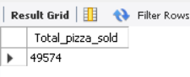

1. **Total Order Placed :-**

SELECT COUNT(DISTINCT(order_id)) AS Total_Order_placed FROM pizza_sales;

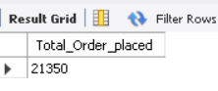

1. **Average Pizza Per Order :-**

SELECT CAST(CAST(SUM(quantity) AS DECIMAL(10,2))/CAST(COUNT(DISTINCT order_id) AS DECIMAL(10,2))AS DECIMAL(10,2)) AS Avg_Pizza_Per_Order FROM pizza_sales;

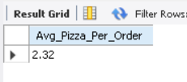

1. **Daily trend for total orders:-**

SELECT DATE_FORMAT(order_date,"%W") AS order_day,COUNT(DISTINCT order_id) AS total_order FROM pizza_sales GROUP BY DATE_FORMAT(order_date,"%W");

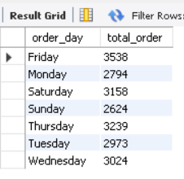

1. **Monthly trend for total orders:-**

SELECT DATE_FORMAT(order_date,"%M") AS order_Month,COUNT(DISTINCT order_id) AS total_order FROM pizza_sales GROUP BY DATE_FORMAT(order_date,"%M") ORDER BY total_order DESC;

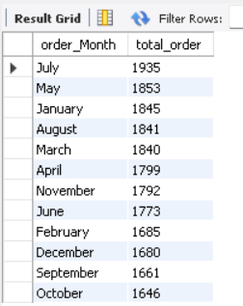

1. **Percentage of sales by pizza category:-**

SELECT pizza_category,CAST(SUM(total_price) AS DECIMAL(10,2)) AS Total_Revenue,CAST(SUM(total_price)*100/(SELECT SUM(total_price) FROM pizza_sales) AS decimal(10,2)) AS PCT FROM pizza_sales GROUP BY pizza_category;

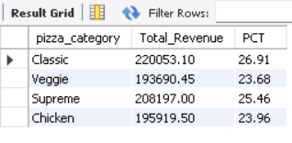

1. **Percentage of Sales by Pizza Size :-**

select pizza_size,cast(sum(total_price) as decimal(10,2)) As Total_Revenue,cast(sum(total_price)*100/(select sum(total_price) from pizza_sales) as decimal(10,2)) As PCT from pizza_sales group by pizza_size order by PCT desc**;**

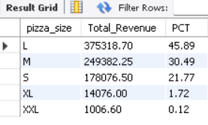

**IN the 1st quarter:-**

select pizza_size,cast(sum(total_price) as decimal(10,2)) As Total_Revenue,cast(sum(total_price)*100/(select sum(total_price) from pizza_sales where quarter(order_date) = 1) as decimal(10,2)) As PCT from pizza_sales where quarter(order_date) = 1 group by pizza_size order by PCT desc;

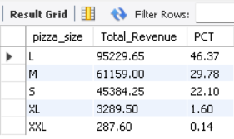

1. **Top 5 best seller by revenue**

SELECT DISTINCT pizza_name, SUM(total_price) AS total_revenue FROM pizza_sales GROUP BY pizza_name ORDER BY total_revenue DESC LIMIT 5;

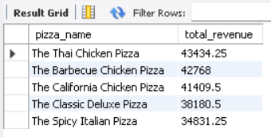

1. **Bottom 5 pizza by revenue**

SELECT DISTINCT pizza_name, SUM(total_price) AS total_revenue FROM pizza_sales GROUP BY pizza_name ORDER BY total_revenue ASC LIMIT 5;

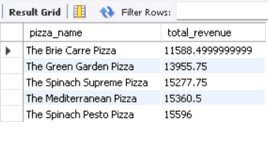

1. **Top 5 pizza by quantity**

**SELECT DISTINCT pizza_name, SUM(quantity) AS total_quantity FROM pizza_sales GROUP BY pizza_name ORDER BY total_quantity DESC LIMIT 5;**

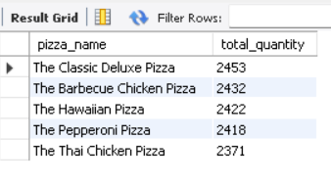

1. **Bottom 5 pizza by quantity**

**SELECT DISTINCT pizza_name, SUM(quantity) AS total_quantity FROM pizza_sales GROUP BY pizza_name ORDER BY total_quantity ASC LIMIT 5;**

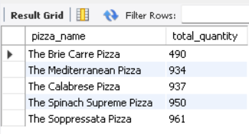

1. **Top 5 pizza by order**

SELECT DISTINCT pizza_name, COUNT(DISTINCT order_id) AS total_order FROM pizza_sales GROUP BY pizza_name ORDER BY total_order DESC LIMIT 5**;**

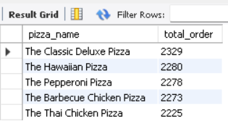

1. **Bottom 5 pizza by order**

**SELECT DISTINCT pizza_name, COUNT(DISTINCT order_id) AS total_order FROM pizza_sales GROUP BY pizza_name ORDER BY total_order ASC LIMIT 5;**

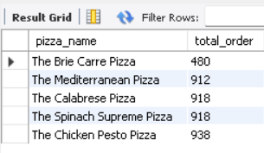

NOTE :-

If you want to apply month, quarter,week filter to above queries you can use where clause. Some examples are given below :-

SELECT SELECT pizza_category,SUM(total_price),SUM(total_price)*100/(SELECT SUM(total_price) FROM pizza_sales where date_format(order_date,"%M") = "January") AS PCT FROM pizza_sales where date_format(order_date,"%M") = "January" GROUP BY pizza_category;

SELECT dayname(order_date) AS order_day,COUNT(DISTINCT order_id) AS total_order FROM pizza_sales where quarter(order_date) GROUP BY dayname(order_date);